Cultura – Alebrijes (Beautiful monsters of Mexico)
“All across Mexico, fantastical creatures can be found dotting the streets, covered in bright colors, giant wings, bulging eyes and viper tongues. These are alebrijes, papier-mâché creations that have become a staple of Mexican folk art. But how did these beautiful monsters come to be? That’s all thanks to one man with a dream. As history has it, after falling into an unconscious state, Pedro Linares dreamed up a series of horrific creatures. Upon waking, he created his first sculpture. Today, his family continues to carry on the tradition of monster-making, keeping Pedro’s visions alive”

Watch the two videos about Alebrijes, then create your own Alebrije by choosing one of the options below, write a paragraph (or a few sentences) in English about what you learned, and take a picture to share your final work.

Making my own Alebrije:

Option one: Draw your own alebrije – Make sure to use lots of colores.

Option two: Check out this link to make your own Alebrije from foil and cardbord.
http://meghcallie.blogspot.com/2015/02/oaxacan-animals-with-foil-and-cardboard.html

Option one: Draw your own
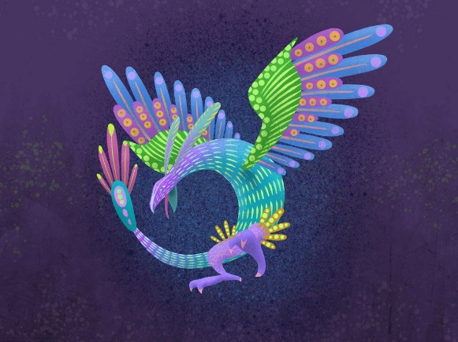

Option two: Make your own
