Write the meaning of each adjective in English.
Alto  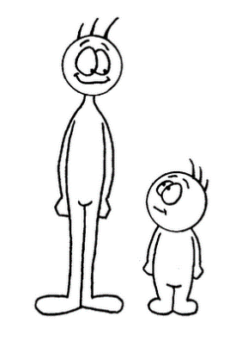  T __ __ __ | Bajo  S __ __ __ __ | Inteligente  S __ __ __ __
Feo  U __ __ __ | Bonito  P __ __ __ __ __ | Guapo  H __ __ __ __ __ __ __
Cómico  F __ __ __ __ | Simpático  N __ __ __ | Antipático  M __ __ __
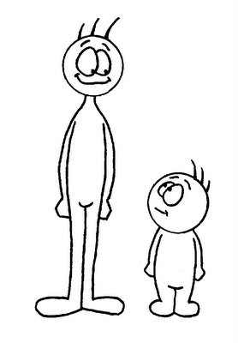
¿Cómo soy yo? | What am I like?
¿Y tú? ¿Cómo eres? | And you? What are you like?
Soy | I am
Eres | You are

Draw a picture of yourself, and write a complete sentence below your picture to describe yourself in Spanish!

______________________________________________________________________________________________________________________________________________________________________________________________________________________________________________________________________________

