Nombre:_______________________________________________ Fecha:_________________
Los Deportes
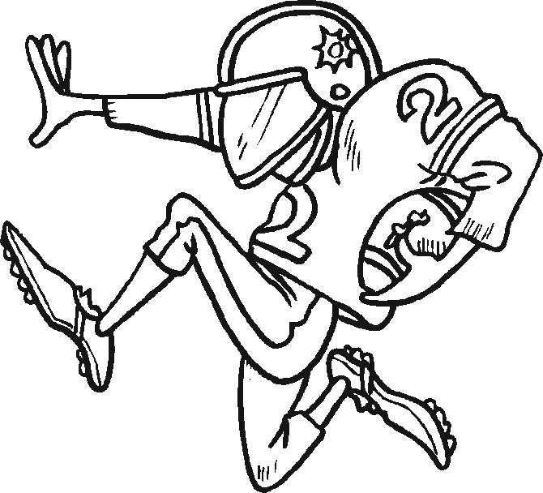
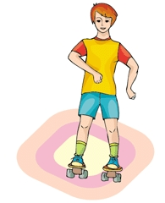
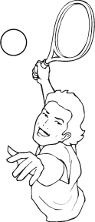
Write the correct Spanish word for each sport. See word bank below.

_____________________ __ ________________________ ________________
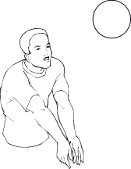
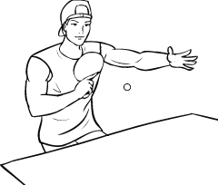
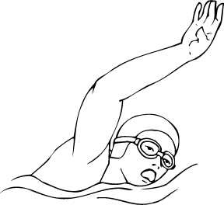

____________________ ____________________________ _______________
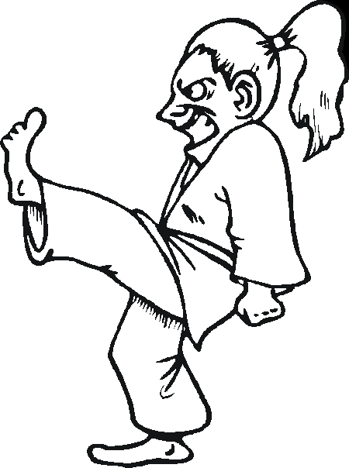
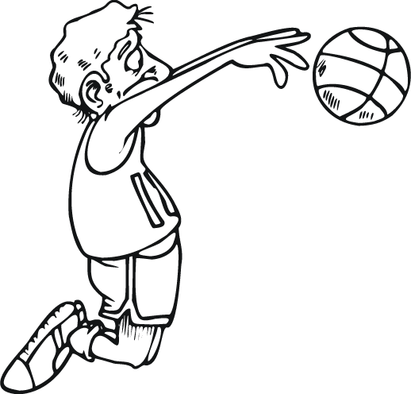

_____________________ ___________________________ ___________________
El Karate, La natación, El tenis, El golf, El baloncesto, El voleibol, El Fútbol Americano, El tenis de mesa, El patinaje,

Then tell me 3 sports you like and 3 sports that you don’t like.

Me gusta:

1)

2)

3)

No me gusta:

1)

2)

3)

Finally draw a picture of your favorite sport.

Mi deporte favorite es ____________________________

